## **Correlation Analysis of Practical Marks in a Combined Project**

## 

### **Introduction**

This study investigates the correlation between practical marks in a combined project that integrated three subjects: Data Structures (DS), Database Management Systems (DBMS), and Java-2. Despite these subjects evaluating different skills—DBMS focusing on SQL proficiency, DS assessing algorithm implementation, and Java-2 measuring software development—the practical marks exhibit a strong correlation, indicating possible grading bias by examiners.

To validate this claim, we conducted a correlation analysis:

1. **Assess the correlation among DS, DBMS, and Java-2 practicals.**
2. **Compare the correlation between Java-1 (Semester 1) and Java-2 (Semester 2) to determine if the combined project influences the grading.**
3. **Examine whether other subjects in Semester 1 and Semester 2 exhibit a similarly strong correlation to confirm the uniqueness of this pattern.**

### **Methodology**

We used the dataset **"college.csv"**, which contains practical marks for all subjects. We computed the Pearson correlation matrix using Matplotlib and Pandas to visualize the relationships.

### 

### 

### 

### 

### 

### 

### **Code Implementation**

import pandas as pd

import matplotlib.pyplot as plt

import seaborn as sns

# Load dataset

file_path = "college.csv"

df = pd.read_csv(file_path)

# Selecting only relevant columns

target_columns = [

"Physics Practical", "Java-1 Practical", "Software Engineering Practical",

"IOT Workshop Practical", "Computer Workshop Practical", "Data Structures using Java Practical",

"DBMS Practical", "Fundamental of Electronics and Electrical Practical", "Java-2 Practical",

"Java-2 Theory", "DBMS Theory", "Data Structures using Java Theory"

]

df = df[target_columns] # Ensure only relevant columns are used

# Define subjects other than trio

sem_1_and_2_subjects = [

"Physics Practical", "Java-1 Practical", "Software Engineering Practical",

"IOT Workshop Practical", "Computer Workshop Practical", "Fundamental of Electronics and Electrical Practical"

]

subject_trio_practical = [

"Java-2 Practical", "DBMS Practical", "Data Structures using Java Practical"

]

# Compute correlation matrix

correlation_matrix = df.corr()

# Extract relevant correlations

ds_dbms_java2_corr = correlation_matrix.loc[subject_trio_practical, subject_trio_practical]

java1_java2_corr = correlation_matrix.loc["Java-1 Practical", "Java-2 Practical"]

other_sem1_sem2_corr = correlation_matrix.loc[sem_1_and_2_subjects, subject_trio_practical]

# Plot correlation matrix for DS, DBMS, Java-2

plt.figure(figsize=(8, 6))

sns.heatmap(ds_dbms_java2_corr, annot=True, cmap="coolwarm", fmt=".2f")

plt.title("Correlation Matrix of DS, DBMS, and Java-2 Practicals")

plt.show()

# Display correlation values

print("Correlation between Java-1 and Java-2 Practical:", java1_java2_corr)

print("Other Semester 1 and Semester 2 Subject Correlations:")

print(other_sem1_sem2_corr)

# Selecting only theory of trio subjects

subject_trio_theory = [

"Java-2 Theory", "DBMS Theory", "Data Structures using Java Theory"

]

# Compute correlation matrix

ds_dbms_java2_theory_corr = correlation_matrix.loc[subject_trio_theory, subject_trio_theory]

# Plot correlation matrix for theory subjects

plt.figure(figsize=(8, 6))

sns.heatmap(ds_dbms_java2_theory_corr, annot=True, cmap="coolwarm", fmt=".2f")

plt.title("Correlation Matrix of Java-2, DBMS, and Data Structures Theory")

plt.show()

### **Results and Discussion**

The correlation analysis highlights the following key findings:

1. **Strong correlation within the DS-DBMS-Java-2 trio**
   * **Java-2 & DBMS Practical:** **0.90**
   * **Java-2 & Data Structures using Java Practical:** **0.94**
   * **DBMS & Data Structures using Java Practical:** **0.90**
   * This suggests that despite each subject evaluating different skills, examiners assigned highly similar marks, likely due to the **combined project.**

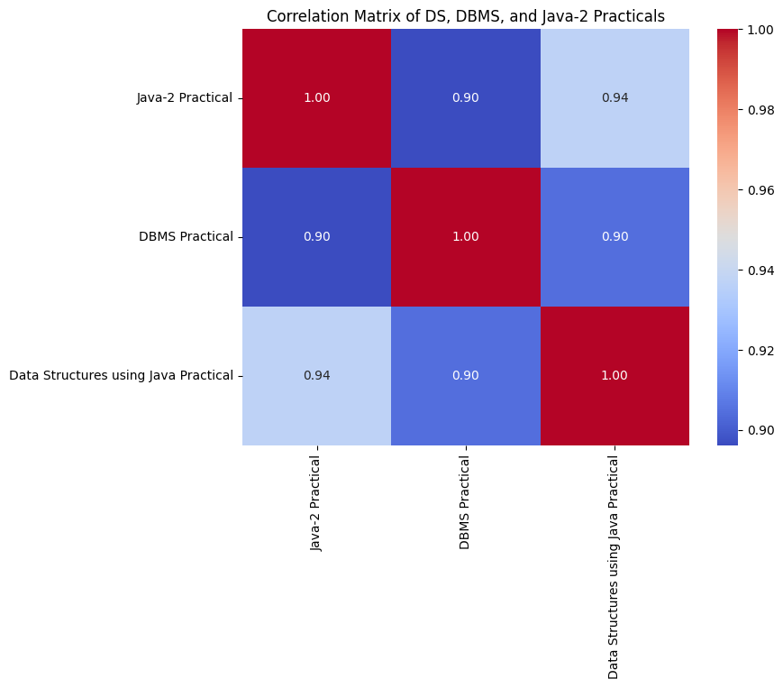

1. **Lower correlation between Java-1 and Java-2**
   * **Java-1 & Java-2 Practical:** **0.39**
   * Since both involve Java programming but were evaluated in different semesters without a combined project, this confirms that the **grading similarity in three subjects was due to the combined project, not subject continuity**.

Correlation between Java-1 and Java-2 Practical: 0.39010499148400124

1. **Weaker correlation of other subjects with the subject trio**
   * Most other subjects, including **Physics, Software Engineering, IOT Workshop, and Computer Workshop**, had correlations ranging from **0.22 to 0.51** with DS, DBMS, and Java-2.
   * This indicates that the **high correlation within the subject trio is an anomaly**, reinforcing the likelihood of **examiners grading the project as a whole rather than differentiating subject-specific aspects**.

Other Semester 1 and Semester 2 Subject Correlations:

**For Java-2 Practical:**

Physics Practical 0.325608

Java-1 Practical 0.390105

Software Engineering Practical 0.223259

IOT Workshop Practical 0.218557

Computer Workshop Practical 0.298241

Fundamental of Electronics and Electrical Pract... 0.511154

**For DBMS Practical:**

Physics Practical 0.361335

Java-1 Practical 0.439030

Software Engineering Practical 0.242534

IOT Workshop Practical 0.272755

Computer Workshop Practical 0.320867

Fundamental of Electronics and Electrical Pract... 0.596819

**For Data Structures using Java Practical:**

Physics Practical 0.324466

Java-1 Practical 0.402300

Software Engineering Practical 0.230358

IOT Workshop Practical 0.225648

Computer Workshop Practical 0.308910

Fundamental of Electronics and Electrical Pract... 0.543530

4. **Correlation in Theory Subjects**

* **Java-2 & DBMS Theory:** 0.78
* **Java-2 & Data Structures using Java Theory:** 0.72
* **DBMS & Data Structures using Java Theory:** 0.78  
  While the correlation in theory subjects is not as strong as in practicals, the moderately high values indicate that students' performances in these subjects followed a similar pattern. This could be due to interrelated concepts or grading leniency rather than a combined project effect.

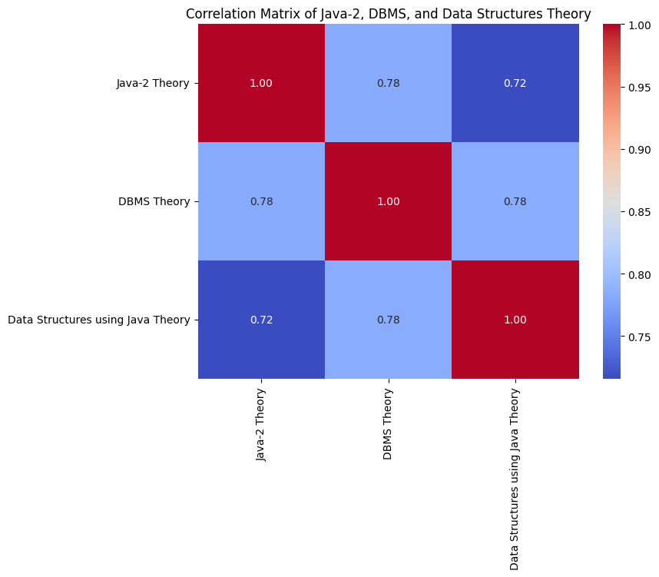

These findings strongly suggest a grading bias in **combined projects**, where examiners **did not differentiate practical marks according to distinct subject competencies**.

### 

### **Conclusion**

The findings indicate that **grading in subject trio may have been influenced by the combined project**, leading to **unintended uniformity in marks** across DS, DBMS, and Java-2 practicals. While each subject was designed to assess distinct skills, the strong correlations suggest that examiners might have **assessed the project holistically rather than subject-specifically**.

By contrast, the lower correlation between **Java-1 and Java-2 practicals** and the weaker correlation of **other Semester 1 and 2 subjects with the subject trio** indicate that such grading patterns are **not common across all subjects**. This strengthens the argument that the combined project was a key factor in the grading similarity.

### **Implications**

* To ensure **fair evaluation**, future assessment frameworks should enforce **clear differentiation of marks** for subjects contributing to a combined project.
* Examiners should be **instructed to evaluate each subject independently**, avoiding the risk of grading bias.
* Institutions could introduce **separate assessment components** within projects, ensuring that subject-specific competencies are **distinctly measured**.